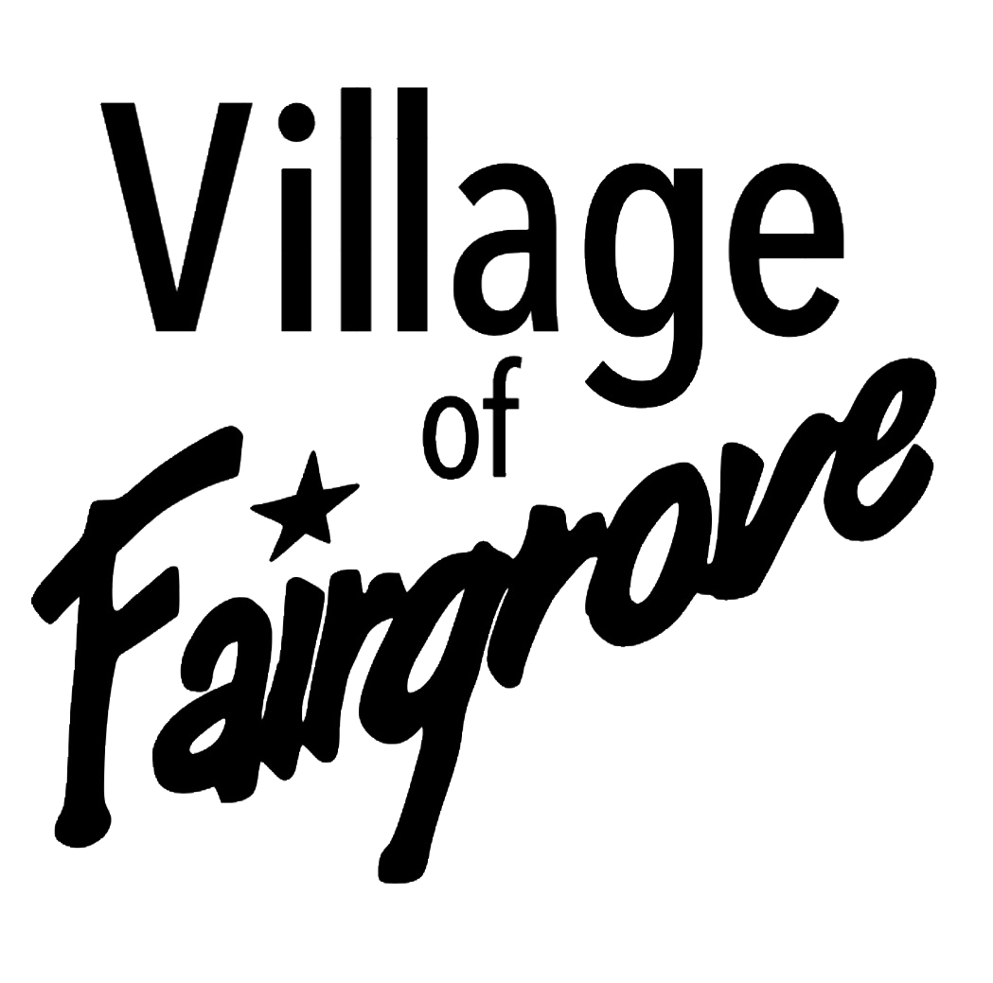
5005 W. Center • PO Box 227

Fairgrove, MI 48733
Phone (989) 693- 6572 Fax (989) 693- 6881
e-mail: VillageofFairgrove@gmail.com
www.villageoffairgrove.org

Special
March 3, 2025 @6:15pm
Budget Hearing

Regular Agenda
March 3, 2025 @ 6:30 pm
- Welcome remarks
- Pledge of Allegiance
- Roll Call
- Approval of Agenda for 2/03/2025
- Approval of Meeting Minutes for Budget Workshop 1/18/2025
- Audience Recognition:
    - 2024-019
- Fire Department: -Chief Young
- Report- D. Young
- Generator back- Maguire
- Auxiliary Fire Fighter- D. Young
- Volunteer Fire Department
- Police Department: - Mitin
- Report
- Buildings and Grounds: -Thomas
- Report
- Tree removal- Liberty & East Center St also- $2,525.00
- Kennedy Cleaning Sewer to estimate $4,180.00
- Monchilov Bill for main street update
- Downtown trees Spring-Thomas- Tabled
- Department Committee Reports-
- Streets- K. Young
- Drainage on Circle St. -update Thomas
- Circle/ Park- Update- K. Young-Tabled
- Center St East- Smith
        - Resolution 2025-003
- Bridge painting- Spring-Thomas – Tabled

    - Lagoon- K. Young/ T. Thomas
      - Report
- Park-Harrison /Spencer
      - Report
- Code Enforcement- Spencer/ K. Young
- Report
- Planning Commission: -Strasz/Sebert
- Report
- Planning Commission Need 1- Sebert/ J. Pustizzi/ Stevens/Morton
        - Minutes need approval
- ZBA- Smith- J. Stevens/ Cramer/ C. Pustizzi
- Emergency Planning- R. Thomas
- Fire Board – Harrison/ Spencer
- Fairgrove Township- K. Young
- Employee Hiring- Sebert/ Harrison
      - Fire Department Chief
- Bean Festival- K. Young
      - Sale of Building– Young/ No answer from Bean Fest-Tabled
    - Village Hall refresh- Young/ Sebert
- Clerk-Treasurer-
- Check Register Report
- Bills to be paid: My member insurance $ 28,145.00
- Budget adjustments $6,017.03 from other lines not Fund equity
- Budget Hearing Resolution 2025-002
- Bookkeeper-Harrison
- Report
- Checking Balances Report
- Old Business
    - FOIA from Township
- New Business
  - Correspondence
- Audience Recognition
- Next Meeting 04/07/2025 @ 6:30 pm

- Clerk- Smith

